Hardware And Components

Assignment Day-4

Task-1: Open your own laptop or desktop (or use an online PC hardware simulator if you don't have access to a real system) and identify the GPU model installed. Write down the GPU's brand, model number, and whether it is integrated or dedicated.

GPU Identification

Details | Information
GPU Brand | NVIDIA
GPU Model | GeForce GTX 1650
GPU Type | Dedicated
Main Use | Gaming, video editing, and graphics-intensive applications
Example | PUBG, Free Fire, or video editing in Adobe Premiere Pro

Task-2: Take a clear photo or screenshot of the cooling system (fan, heatsink, or liquid cooling setup) inside your PC or from a PC hardware simulator. Label the main cooling components and briefly describe their function.
Step1- CPU cooling components including fan, heatsink, thermal paste, processor, and motherboard.

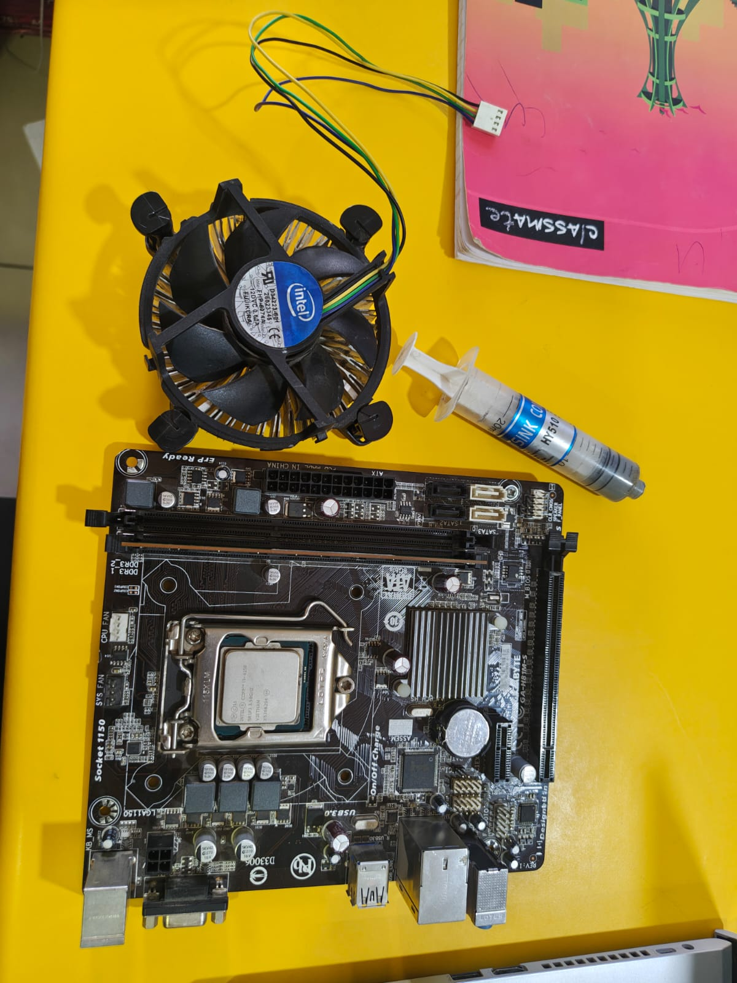

Step2: Colling system installation over the Processor.
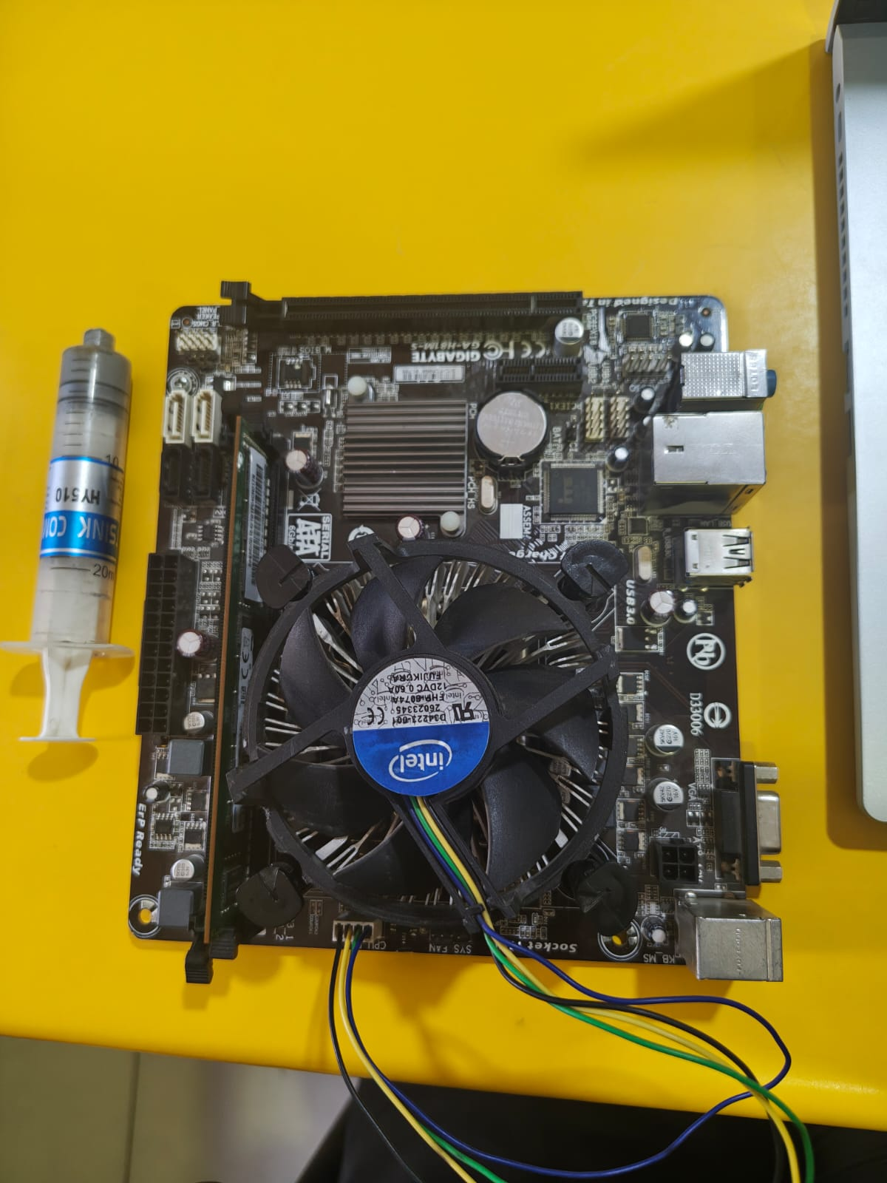

Step3: And there components-
Component | Function
CPU Cooling Fan | Pushes air through the heatsink to remove heat.
Heatsink | Absorbs and dissipates heat from the CPU.
Thermal Paste | Improves heat transfer between CPU and heatsink.
CPU | Generates heat while processing data.
Motherboard | Holds and connects all hardware components.

Task-3: Create a comparison table listing at least 3 differences between air cooling and liquid cooling systems for GPUs, including factors like cost, efficiency, and maintenance.

Air Cooling vs Liquid Cooling for GPUs

Factor | Air Cooling | Liquid Cooling
Cooling Method | Uses fans and heatsinks to remove heat from the GPU. | Uses a liquid coolant that carries heat away from the GPU to a radiator.
Cost | Generally cheaper and more affordable. | Usually more expensive due to the pump, radiator, tubing, and coolant.
Cooling Efficiency | Provides good cooling for normal gaming and everyday use. | Usually provides better cooling, especially during heavy workloads and overclocking.
Noise Level | Fans can become noisy when the GPU gets hot. | Can be quieter in some setups, although the pump and radiator fans still produce noise.
Maintenance | Low maintenance; mainly requires cleaning dust from the fans and heatsink. | Requires more care because of the pump, radiator, and tubing; leaks are also a possible concern.
Installation | Simple and easy to install. | More complicated to install and requires more space in the PC case.
Best Use | Suitable for regular gaming, office work, and general use. | Suitable for high-performance gaming, heavy workloads, and GPU overclocking.

Task-4: Imagine you are building a gaming PC for streaming IPL matches and playing graphics-heavy games. Choose between air cooling and liquid cooling for your GPU, and justify your choice in 3-4 sentences based on your research.
I would choose liquid cooling for the GPU because a gaming PC used for graphics-heavy games can produce a lot of heat. Liquid cooling generally provides better heat management during long gaming sessions and helps maintain stable performance. It can also help keep temperatures and fan noise under control while streaming IPL matches. Although it costs more and requires more maintenance than air cooling, I would prefer it for a high-performance gaming and streaming PC.

